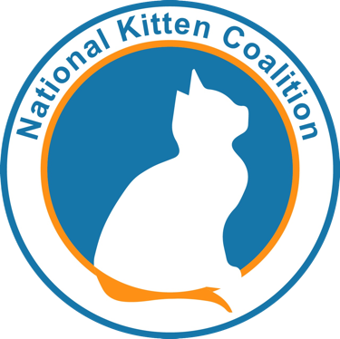
COVID-19 statement: In an effort to support those helping kittens during this time, The National Kitten Coalition continues to provide free webinars that teach not only shelters and rescues—but also those good Samaritans in your community who many not be as familiar with kitten care—the basics on a variety of life-saving topics like how to prepare for fostering kittens, bottle feeding young kittens and caring for pregnant and nursing moms with their kittens. The link to our archived webinars can be found here.
NKC also encourages fostering in your own community and donating kitten foster supplies to pet food banks and animal shelters.
The National Kitten Coalition endorses the following organizations’ recommendations to stem the impacts of COVID-19 crisis: Association for the Animal Welfare Advancement, American Pets Alive!, American Society for the Prevention of Cruelty to Animals, Best Friends, The Humane Society of the United States, National Animal Control Association, University of Wisconsin School of Veterinary Medicine, University of Florida Maddie's Shelter Medicine Program and University of California Davis Koret Shelter Medicine Program.
Spay/neuter COVID-19 statement: NKC supports recommendations to suspend routine spay/neuter surgeries during this COVID-19 crisis in an effort to keep the animal welfare and veterinary communities healthy, avoid overloading local hospitals and conserve PPE for the human medical community and for emergency veterinary cases.
NKC recognizes the repercussions suspending routine spay/neuter surgeries will have on the kitten population, and will continue providing educational resources to the public, animal welfare and veterinary communities to help caregivers in their efforts to save kittens. Specifically, NKC is expanding our webinar schedule, providing Kitten Tutor™ handouts and infographics and offering personalized Workshop Webinars to shelters. NKC will also be partnering with other national organizations to launch COVID-specific campaigns in an effort to help as many caregivers and kittens as possible.
TNR COVID-19 statement: NKC supports recommendations to suspend TNR services during the COVID-19 crisis for cats and kittens that are at no imminent risk in their outdoor homes. Only cats or kittens which are significantly sick or injured, or in immediate danger, should be considered for TNR during this time.
Kitten intake COVID-19 statement: In an effort to balance human and animal health and safety, NKC endorses The University of Wisconsin School of Veterinary Medicine's recommendations:
- to cease the intake of healthy kittens of any age during the COVID-19 crisis; and
- to intake only cats and kittens which are significantly sick or injured, or are at significant risk (cruelty, neglect), during the crisis.
We want to ensure that kittens that would otherwise be turned into shelters receive any care they would need, and to that end we will continue to make available at no cost our webinars. These detailed presentations will inform those who are willing to care for the kittens, during and after the COVID-19 crisis, how to prepare for fostering kittens, bottle feeding young kittens and caring for pregnant and nursing moms with their kittens. We will be adding to the online Kitten Tutor™ resources we have on our website which focus on particular topics of commons concern.

